Creating a Course Reading List Link in Blackboard
NOTES:
- If you work with a Blackboard course designer, please include them in this process.
- If you work with the Libraries to create your reading lists, please continue to work with them and follow the guidelines at: http://libraries.wsu.edu/services/reserves-request

- Enter Blackboard at learn.wsu.edu and open your course.
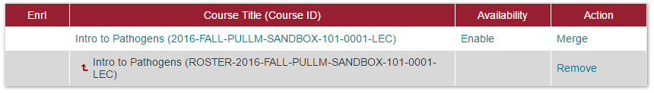

- In the left panel, create or use an existing content area called “Leganto.”
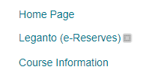

- Open the Leganto content area. From the Tools menu, add the tool labeled “Leganto.”
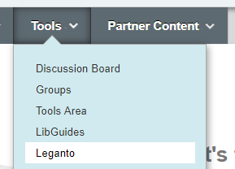

- Provide a name and (optional) description for the link to your reading list and submit.
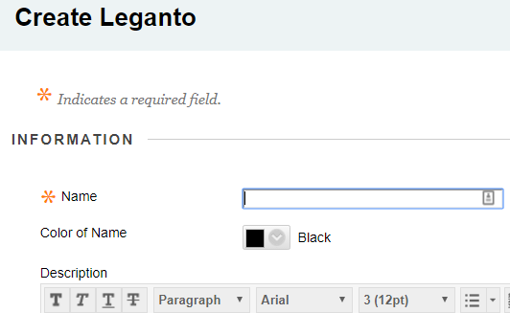

- A short video showing the same: https://www.screencast.com/t/X28Fjou4.

